M. Lukman ID 2301929493

Question set 1 answer

1. Species is a subclass of Genus
2. Specimen is a subtype of Species
3. 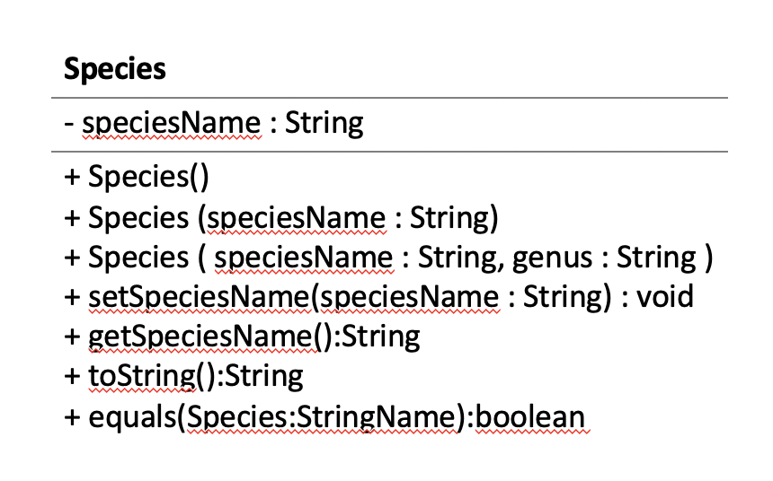
4. you can just use the toString from the lowest inheritance to print everything(the toString from the super), you could change and get the value of super from subclass if you use override.
5. i. because there is nothing wrong on the code, it will generate error if they annotated override and doesn’t override method declared in the super or if there is a parameter on the toString().

Question set 2 answer

1. Wrapping data together to a single unit
2. It hide important data from user, its easy to change the code and maintain it, allow access to a level without showing the complex details.
3. getName,getTOA
4. private String name, private int cageNumber, private Species toa
5. public class Genus {  
    private String genus;  
     
    Genus(){}  
     
    Genus(String genus){  
    this.genus = genus;  
    }  
     
    public String getGenus() {  
    return genus;  
    }  
     
    public void setGenus(String genus) {  
    this.genus = genus;  
    }  
     
    @Override  
    public String toString() {  
    return "Genus{" + "genus='" + genus + '\'' + '}';  
    }  
   }
6. the advantage are there are less duplicate code the disadvantage is specimen need species to work

Question Set 3 answer

1. add description:String in specimen
2. make static totalSpecimen = 0; { totalSpecimen += 1} and then just print out System.outprintln(Specimen.totalSpecimen)
3. class Node {  
   String Name;

String Specimen;  
String etc…

}  
class LinkedList{  
Node head;  
insert(String Name,String Specimen…){

Node node = new Node();

Node.name = name;

Node.Specimen = Specimen;

If (head == null) {

head = node; } else {

Node n = head;

While (n.next != null) {

n = n.next;

} n.next = node;

}

}

Show(){

Node node = head;

While( node != null) {

System.out.println(“name = “+ node.name + “specimen =” +node specimen);

node = node.next;

}

Question set 4 answer

1. list contain elements in sequential order use insert and remove ,Stack contains element that the last one that got in is the first one to get out use push and pop, queue contains element that the first one in the first one out use enqueue and dequeue. (sorry I don’t quite understand the question)